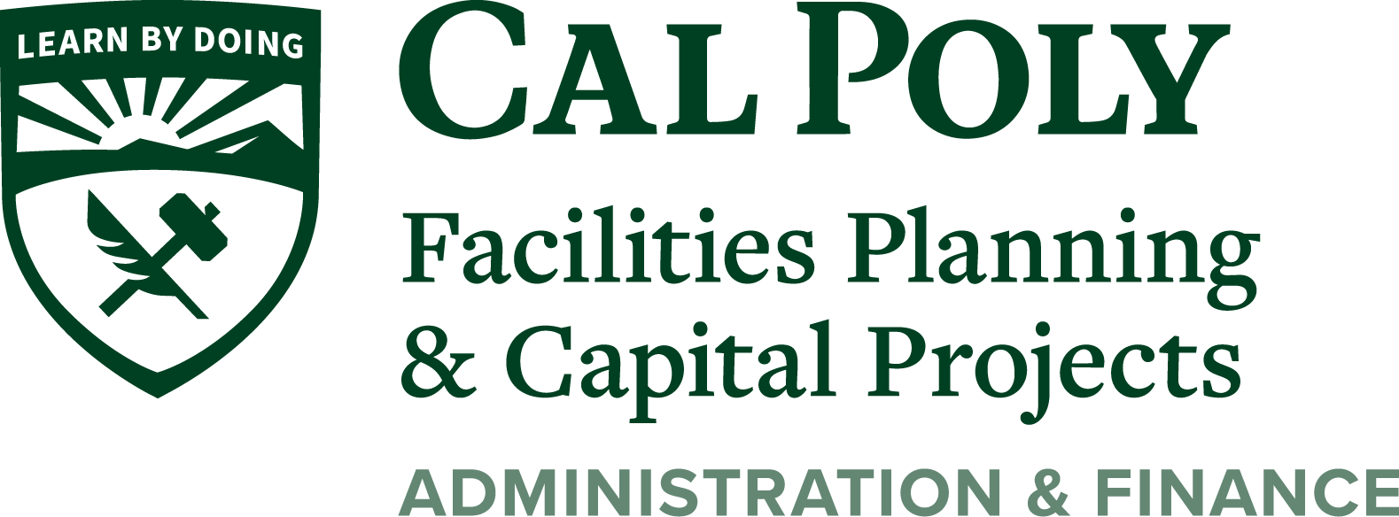

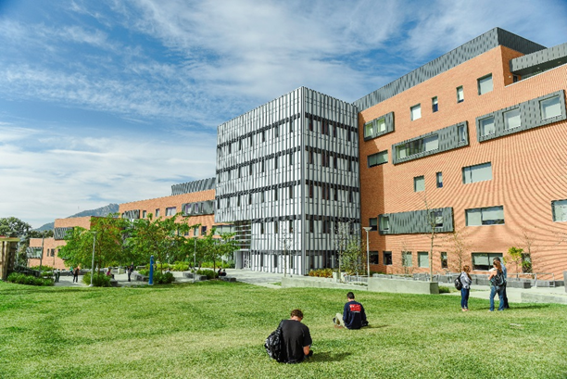

University Standards
January 2020

THIS PAGE INTENTIONALLY BLANK

